Trabajo práctico integrador Base de Datos Gail Judith Yarcho

Crear base de datos: Create batadase proy_integrador_bd_gailyarcho

Create Tabla Oradores

[CREATE](http://localhost/phpmyadmin/url.php?url=https://dev.mysql.com/doc/refman/8.0/en/create-table.html) [TABLE](http://localhost/phpmyadmin/url.php?url=https://dev.mysql.com/doc/refman/8.0/en/create-table.html) `proy_int_bd_gailyarcho`.`oradores` (`id_orador` INT(10) [NOT](http://localhost/phpmyadmin/url.php?url=https://dev.mysql.com/doc/refman/8.0/en/logical-operators.html%23operator_not) NULL , `nombre` VARCHAR(50) [NOT](http://localhost/phpmyadmin/url.php?url=https://dev.mysql.com/doc/refman/8.0/en/logical-operators.html%23operator_not) NULL , `apellido` VARCHAR(50) [NOT](http://localhost/phpmyadmin/url.php?url=https://dev.mysql.com/doc/refman/8.0/en/logical-operators.html%23operator_not) NULL , `mail` VARCHAR(80) [NOT](http://localhost/phpmyadmin/url.php?url=https://dev.mysql.com/doc/refman/8.0/en/logical-operators.html%23operator_not) NULL , `tema` VARCHAR(250) [NOT](http://localhost/phpmyadmin/url.php?url=https://dev.mysql.com/doc/refman/8.0/en/logical-operators.html%23operator_not) NULL , `fecha_alta` DATETIME [NOT](http://localhost/phpmyadmin/url.php?url=https://dev.mysql.com/doc/refman/8.0/en/logical-operators.html%23operator_not) NULL [DEFAULT](http://localhost/phpmyadmin/url.php?url=https://dev.mysql.com/doc/refman/8.0/en/miscellaneous-functions.html%23function_default) [CURRENT_TIMESTAMP](http://localhost/phpmyadmin/url.php?url=https://dev.mysql.com/doc/refman/8.0/en/date-and-time-functions.html%23function_current_timestamp) ) ENGINE = InnoDB;

Crear la clave primaria para la tabla oradores

[ALTER](http://localhost/phpmyadmin/url.php?url=https://dev.mysql.com/doc/refman/8.0/en/alter-table.html) [TABLE](http://localhost/phpmyadmin/url.php?url=https://dev.mysql.com/doc/refman/8.0/en/alter-table.html) `oradores` ADD PRIMARY KEY(`id_orador`);

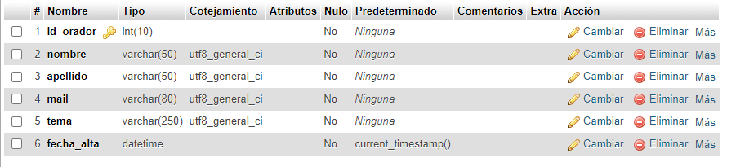

[ALTER](http://localhost/phpmyadmin/url.php?url=https://dev.mysql.com/doc/refman/8.0/en/alter-table.html) [TABLE](http://localhost/phpmyadmin/url.php?url=https://dev.mysql.com/doc/refman/8.0/en/alter-table.html) `oradores` CHANGE `id_orador` `id_orador` INT(10) [NOT](http://localhost/phpmyadmin/url.php?url=https://dev.mysql.com/doc/refman/8.0/en/logical-operators.html%23operator_not) NULL AUTO_INCREMENT;

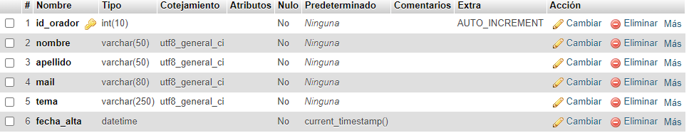

INSERT INTO `oradores` (`id_orador`, `nombre`, `apellido`, `mail`, `tema`, `fecha_alta`) VALUES (NULL, 'Steve', 'Jobs', 'steve@hotmail.com', 'Desde fuentes elegantes a un imperio informático', current_timestamp());

INSERT INTO `oradores` (`id_orador`, `nombre`, `apellido`, `mail`, `tema`, `fecha_alta`) VALUES (NULL, 'Bill', 'Gates', 'bill@gmail.com', 'Como utilizar conocimiento de otros para crear un imperio', current_timestamp());

INSERT INTO `oradores` (`id_orador`, `nombre`, `apellido`, `mail`, `tema`, `fecha_alta`) VALUES (NULL, 'Ada', 'Lovelace', 'ada@outlook.com', 'Sin nosotras esto no hubiese existido Parte 1', current_timestamp());

[INSERT](http://localhost/phpmyadmin/url.php?url=https://dev.mysql.com/doc/refman/8.0/en/insert.html) INTO `oradores` (`id_orador`, `nombre`, `apellido`, `mail`, `tema`, `fecha_alta`) [VALUES](http://localhost/phpmyadmin/url.php?url=https://dev.mysql.com/doc/refman/8.0/en/miscellaneous-functions.html%23function_values) (NULL, 'Hedy', 'Lamarr', 'hedy@hotmail.com', 'Si no fuera por nosotras esto no hubiese existido Parte 2', [current_timestamp](http://localhost/phpmyadmin/url.php?url=https://dev.mysql.com/doc/refman/8.0/en/date-and-time-functions.html%23function_current_timestamp)());

INSERT INTO `oradores` (`id_orador`, `nombre`, `apellido`, `mail`, `tema`, `fecha_alta`) VALUES (NULL, 'Minnie', 'Mouse', 'minnie@disney.com', 'Hagamos de esto algo divertido', current_timestamp());

[INSERT](http://localhost/phpmyadmin/url.php?url=https://dev.mysql.com/doc/refman/8.0/en/insert.html) INTO `oradores` (`id_orador`, `nombre`, `apellido`, `mail`, `tema`, `fecha_alta`) [VALUES](http://localhost/phpmyadmin/url.php?url=https://dev.mysql.com/doc/refman/8.0/en/miscellaneous-functions.html%23function_values) (NULL, 'Donald', 'Duck', 'donald@disney.com', 'Esto me pone muy nervioso', [current_timestamp](http://localhost/phpmyadmin/url.php?url=https://dev.mysql.com/doc/refman/8.0/en/date-and-time-functions.html%23function_current_timestamp)());

[INSERT](http://localhost/phpmyadmin/url.php?url=https://dev.mysql.com/doc/refman/8.0/en/insert.html) INTO `oradores` (`id_orador`, `nombre`, `apellido`, `mail`, `tema`, `fecha_alta`) [VALUES](http://localhost/phpmyadmin/url.php?url=https://dev.mysql.com/doc/refman/8.0/en/miscellaneous-functions.html%23function_values) (NULL, 'Dippy', 'Dawg', 'dippy@disney.com', 'No entiendo nada', [current_timestamp](http://localhost/phpmyadmin/url.php?url=https://dev.mysql.com/doc/refman/8.0/en/date-and-time-functions.html%23function_current_timestamp)());

[INSERT](http://localhost/phpmyadmin/url.php?url=https://dev.mysql.com/doc/refman/8.0/en/insert.html) INTO `oradores` (`id_orador`, `nombre`, `apellido`, `mail`, `tema`, `fecha_alta`) [VALUES](http://localhost/phpmyadmin/url.php?url=https://dev.mysql.com/doc/refman/8.0/en/miscellaneous-functions.html%23function_values) (NULL, 'Jacinta', 'Pichimahuida', 'jacinta@aol.com', 'Como enseñar código a niños en el aula', [current_timestamp](http://localhost/phpmyadmin/url.php?url=https://dev.mysql.com/doc/refman/8.0/en/date-and-time-functions.html%23function_current_timestamp)());

[INSERT](http://localhost/phpmyadmin/url.php?url=https://dev.mysql.com/doc/refman/8.0/en/insert.html) INTO `oradores` (`id_orador`, `nombre`, `apellido`, `mail`, `tema`, `fecha_alta`) [VALUES](http://localhost/phpmyadmin/url.php?url=https://dev.mysql.com/doc/refman/8.0/en/miscellaneous-functions.html%23function_values) (NULL, 'Clark', 'Kent', 'clark@krypton.com', 'Para aprender a programar se necesitan superpoderes', [current_timestamp](http://localhost/phpmyadmin/url.php?url=https://dev.mysql.com/doc/refman/8.0/en/date-and-time-functions.html%23function_current_timestamp)());

[INSERT](http://localhost/phpmyadmin/url.php?url=https://dev.mysql.com/doc/refman/8.0/en/insert.html) INTO `oradores` (`id_orador`, `nombre`, `apellido`, `mail`, `tema`, `fecha_alta`) [VALUES](http://localhost/phpmyadmin/url.php?url=https://dev.mysql.com/doc/refman/8.0/en/miscellaneous-functions.html%23function_values) (NULL, 'Feli', 'Noslindos', 'miau@gatitos.com', 'Que lindos que son los gatitos', [current_timestamp](http://localhost/phpmyadmin/url.php?url=https://dev.mysql.com/doc/refman/8.0/en/date-and-time-functions.html%23function_current_timestamp)());

